GAIL NDA form completion process

From the GAIL Resources website, click on the Resources menu at the top and choose the Forms and Policies option. Then select the Nondisclosure Agreement Forms option.
https://support.dar.uga.edu/GAIL/
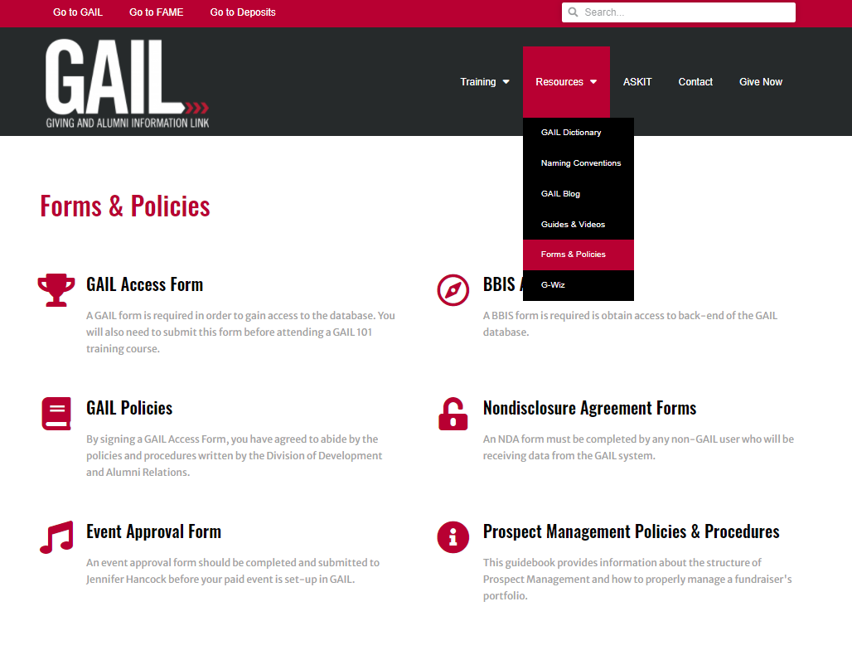
The Forms & Policies page will display the information and requirements for allowing another person/company certain shareable GAIL data.
If you are a UGA full time employee that has a business need to share data with another person or a contracted vendor, you will choose one of the options marked with a blue arrow in the image below. A full time UGA employee will initiate both form types (depending on which is needed) and enter the Requester section for the person or vendor they are wishing to share GAIL data with.
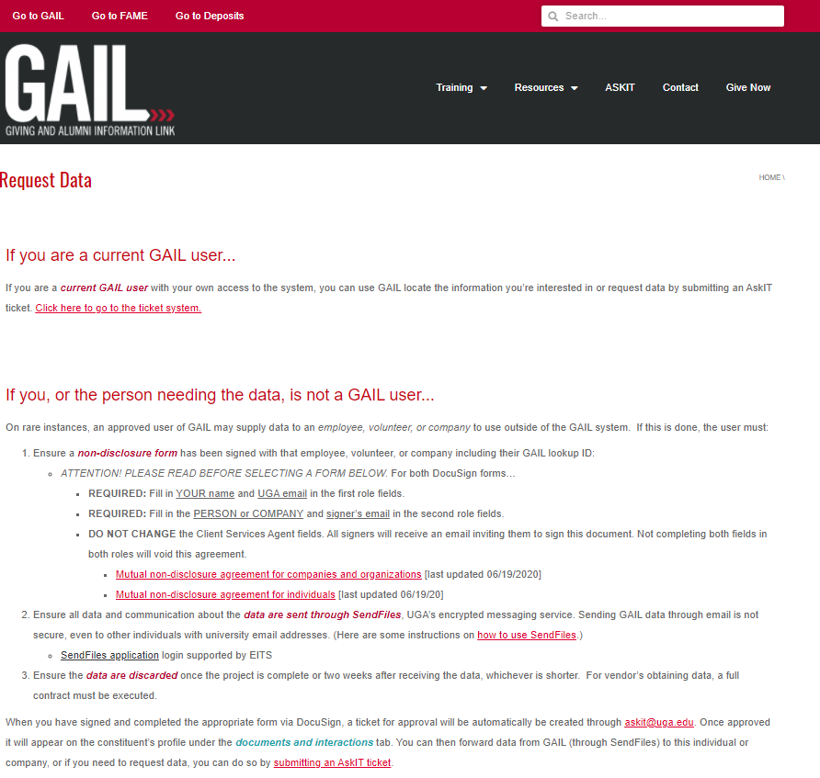

Person / Individual <- OR -> Company/Business
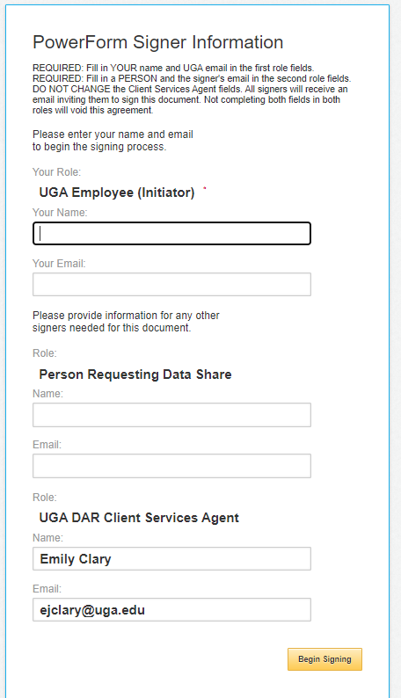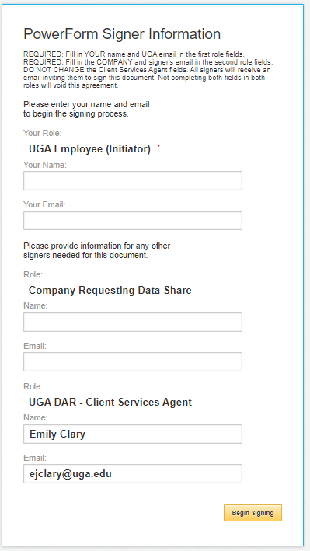

As the Initiator (full time UGA employee), you will fill in the information for the UGA Employee (Initiator) and the Person Requesting Data Share sections as shown above.

As you can see, the last section called UGA DAR – Client Services Agent is already auto-populated so that the completed forms will be automatically sent to the Client Services team for processing and recording into the GAIL system.

After you’ve entered information in the first 2 sections, click the Begin Signing button.

The DocuSign form will open in a web browser. You’ll need to click the box indicated by a yellow arrow in the image below (I agree to…) and click the Continue button at the top right of the document.

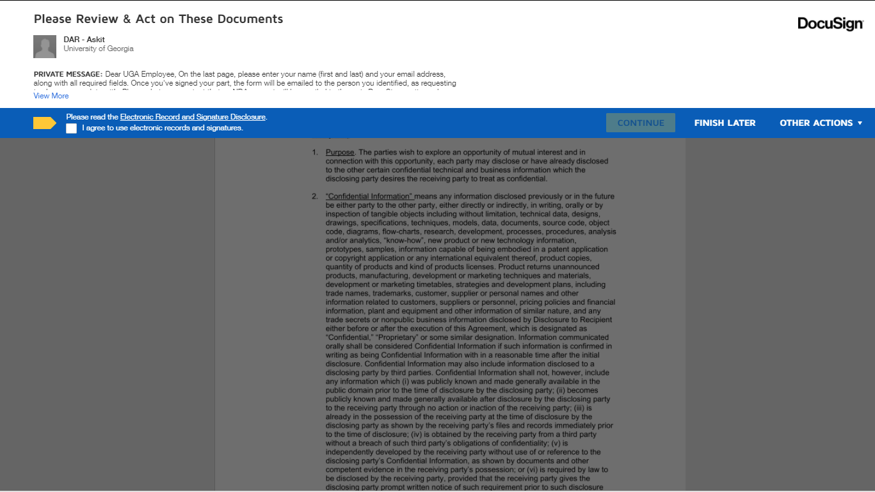

Next, click the START button and it will take you to the point in the document where you will enter your information & signature. See image below.

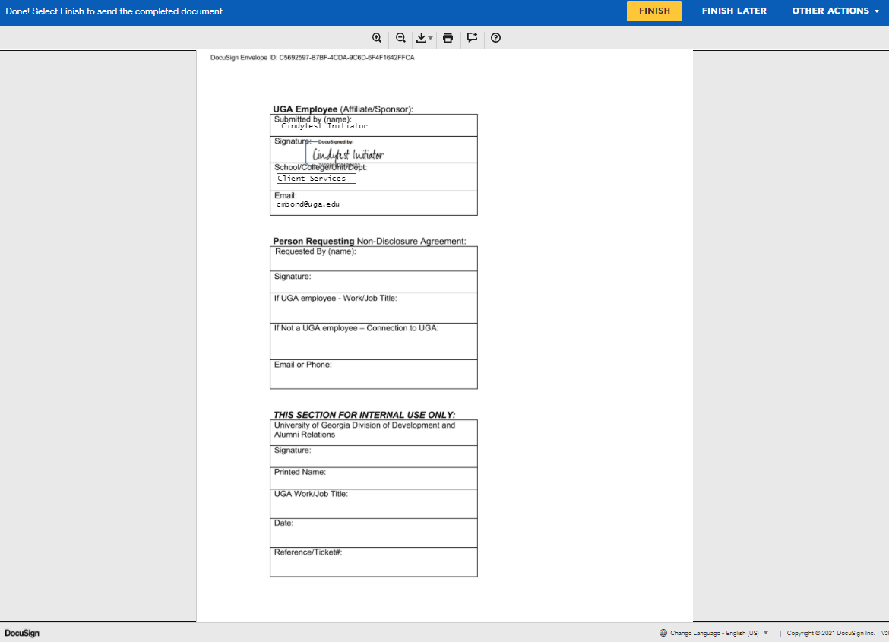
When you click the FINISH button, the document will be emailed to the Person Requesting based on information you/the Initiator entered.

The FINISH button will launch an email to your inbox that contains the NDA form you just initiated.
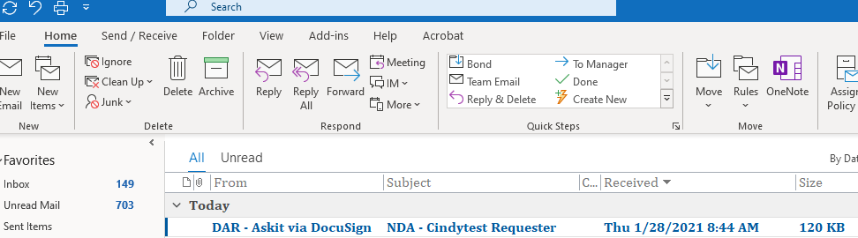

Inside the email, click the REVIEW DOCUMENT link, this will launch the next step in the DocuSign process.
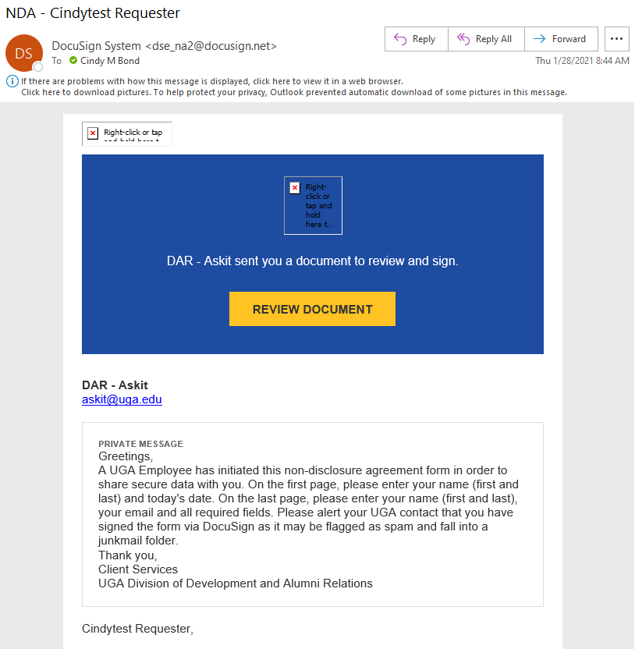

The Review Document button will take you to the DocuSign NDA for the Requester to complete their part. To get started, click the CONTINUE button at the top right section of the screen.
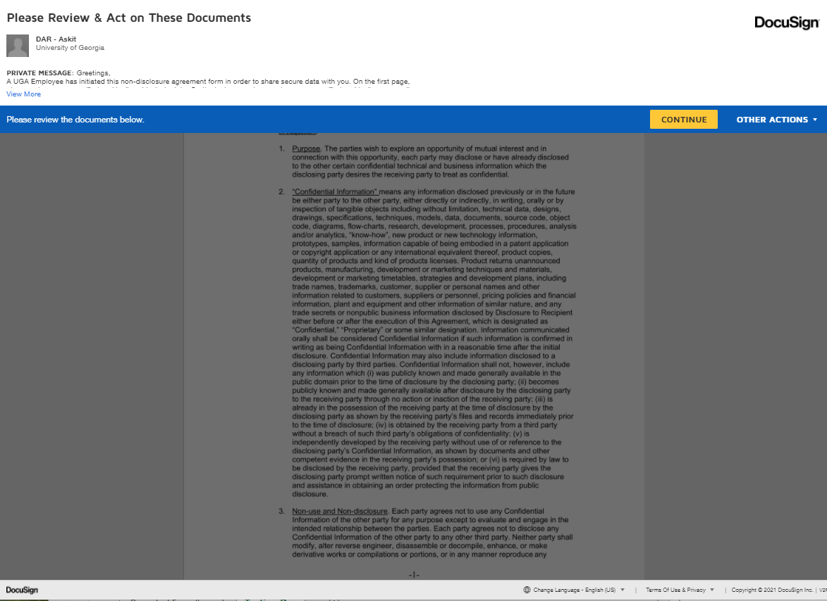
Here you can see that the information entered for the PERSON REQUESTING is now populated in the first section of the form. Click CONTINUE then click START and it will take you to the section of the form that the Requester must complete and sign.
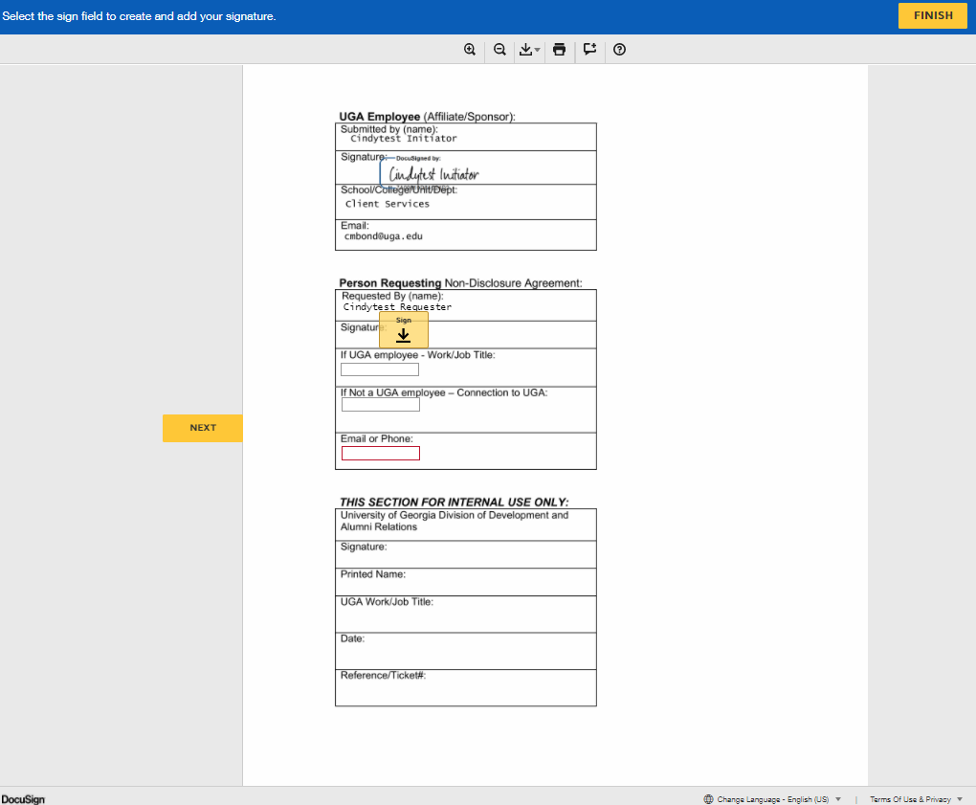
Click FINISH once all fields have been entered. The full document with signatures for Initiator and Requester will now appear on your screen. You can click CLOSE when you are finished reviewing it.
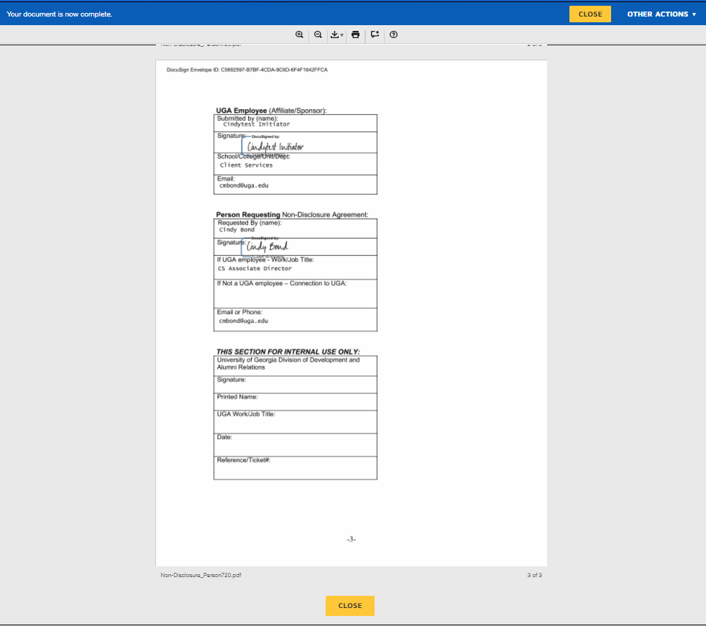
cv
cv
Upon clicking the CLOSE button (either one), the completed form will display on your screen for you to view/save/finish the process.
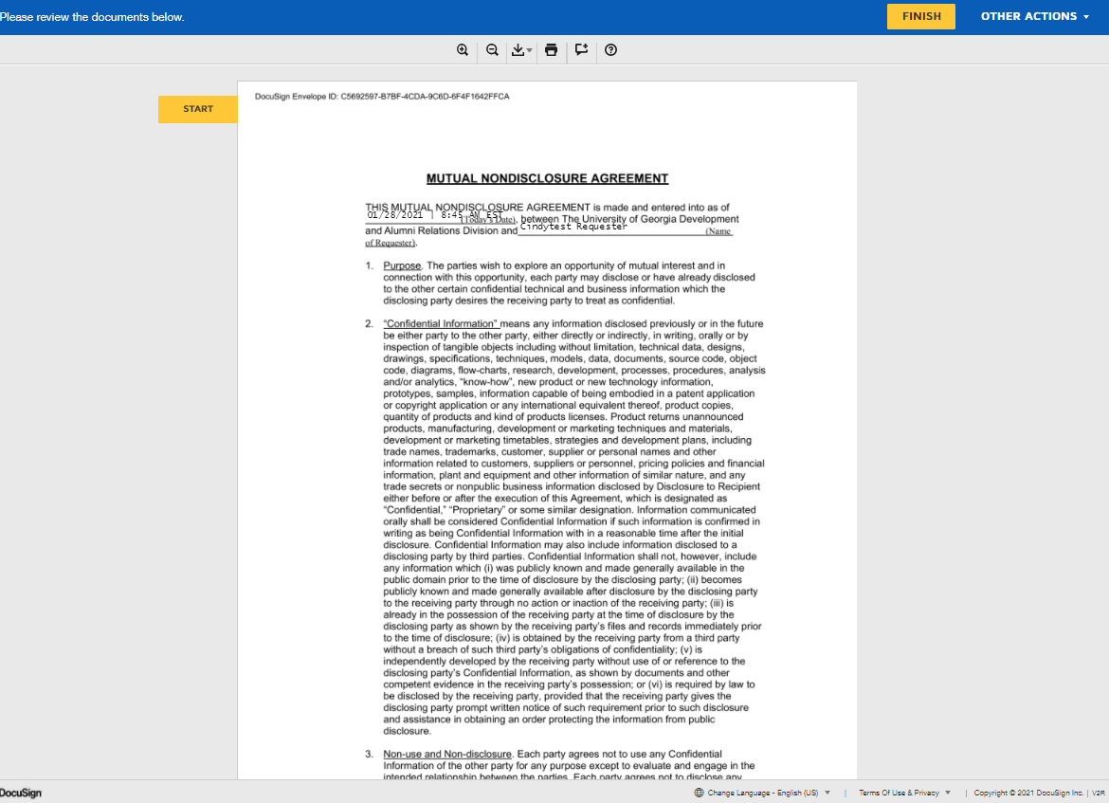
cv

The completed form will be sent to the Client Services team where it will be reviewed, approved, and processed. A final copy of the NDA will be added to the Requester’s record in the GAIL system, under the Documentation and Interactions tab (see example below).

