Process for submitting a FAME user access request form

Navigate to support.dar.uga.ed/FAME
Click on the Request Access or the Training + Getting Access buttons as shown below.
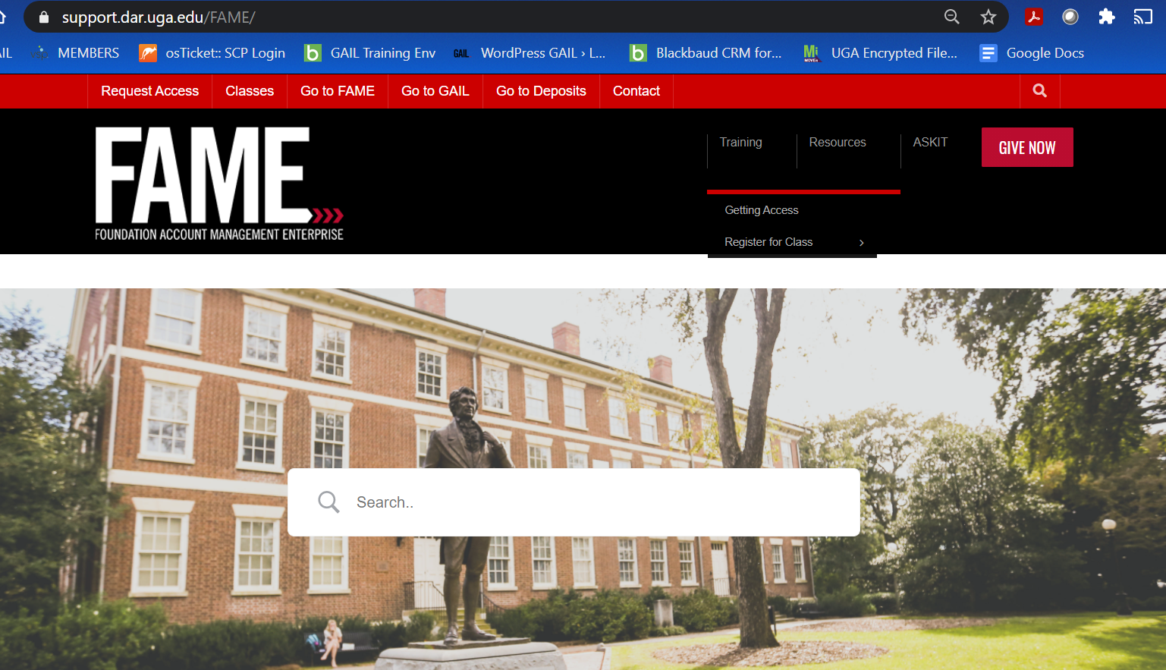
The following page will display. There are 3 steps in getting access to the FAME system. Under Step 1, you will click the link for “access form”. Don’t forget to follow through with Steps 2 and 3 once your form is submitted.
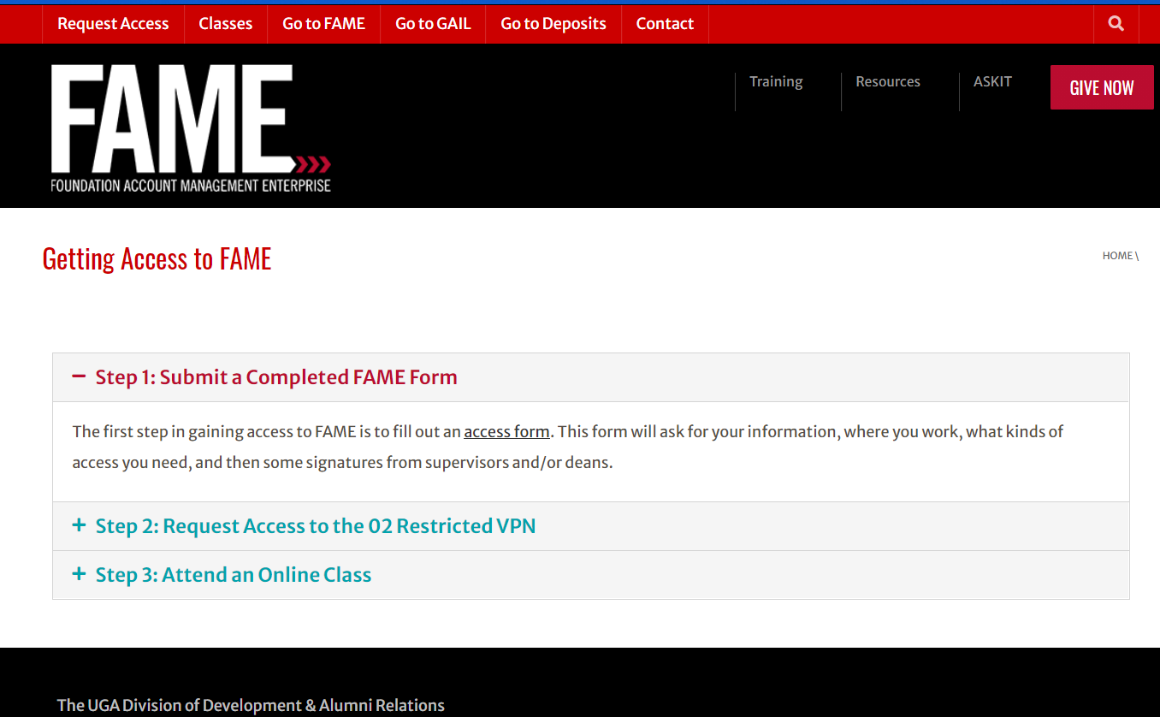

You will enter information for yourself, your Department Head, and your VP/Dean/Director of your school/college/unit. This will direct the electronic movement of the form in obtaining signatures so be sure you enter the names and email addresses correctly.
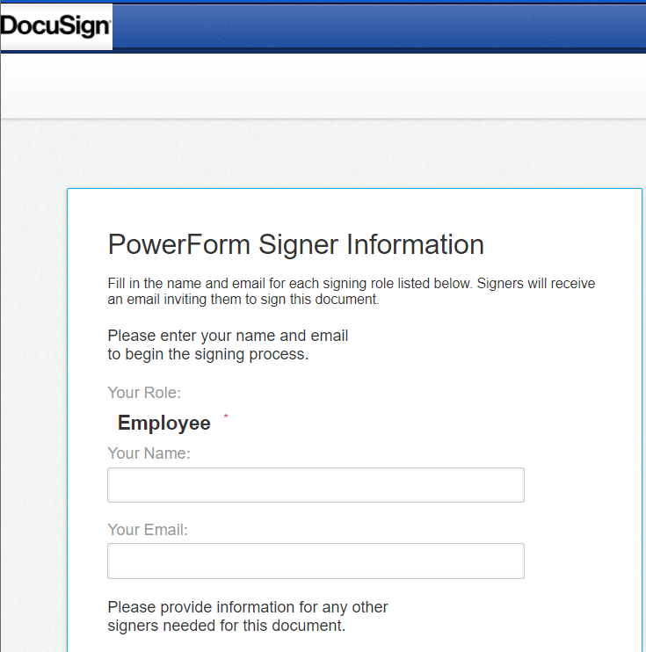
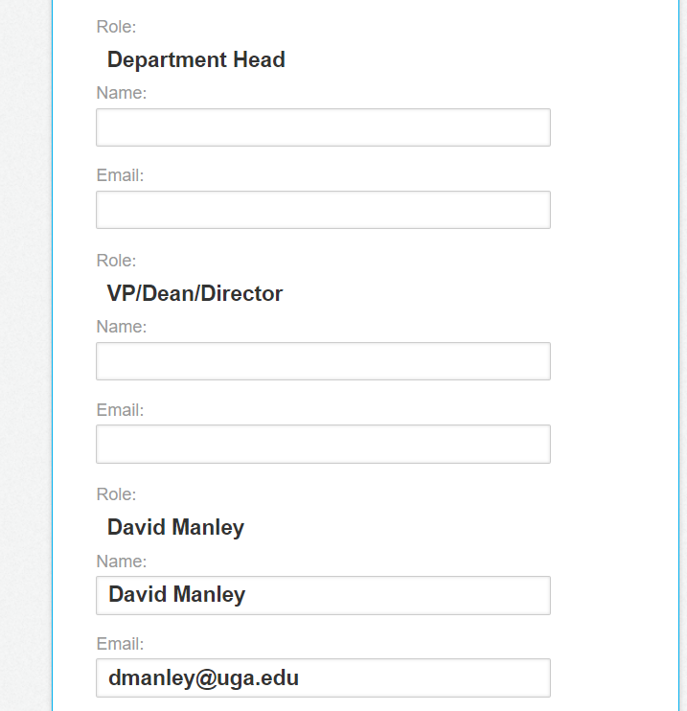
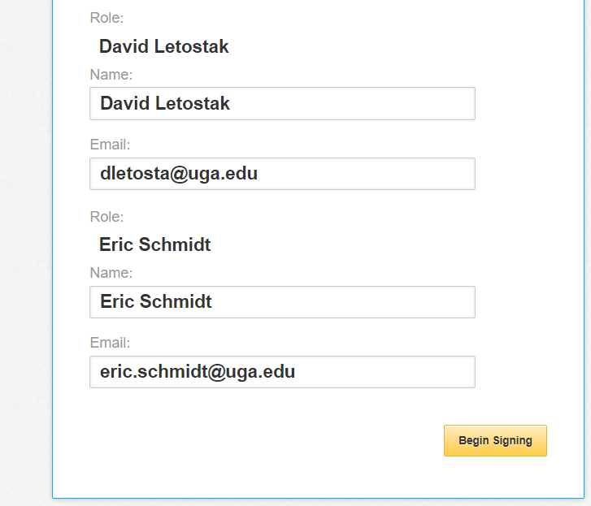
Once you’ve entered information for the first 3 Roles, click Begin Signing button which will initiate the access form, as shown below.

To start completing the form, click the box for I agree to use electronic records and signatures as indicated by the yellow arrow. At that time, the CONTINUE button will become available, click it to continue.
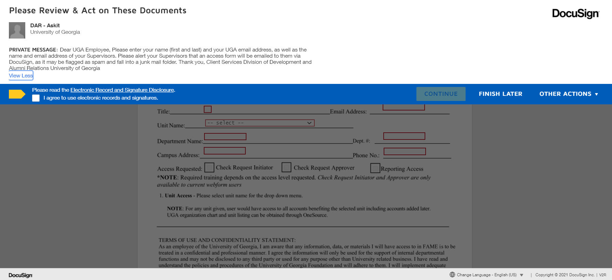

The red boxes shown below indicate required fields. Your UGA MyID is not your UGA CAN # (810/811), it typically includes your initials and perhaps numbers (ex: abc12345).
***Do not click the FINISH button until after you’ve entered all required information and signed the form at the bottom.
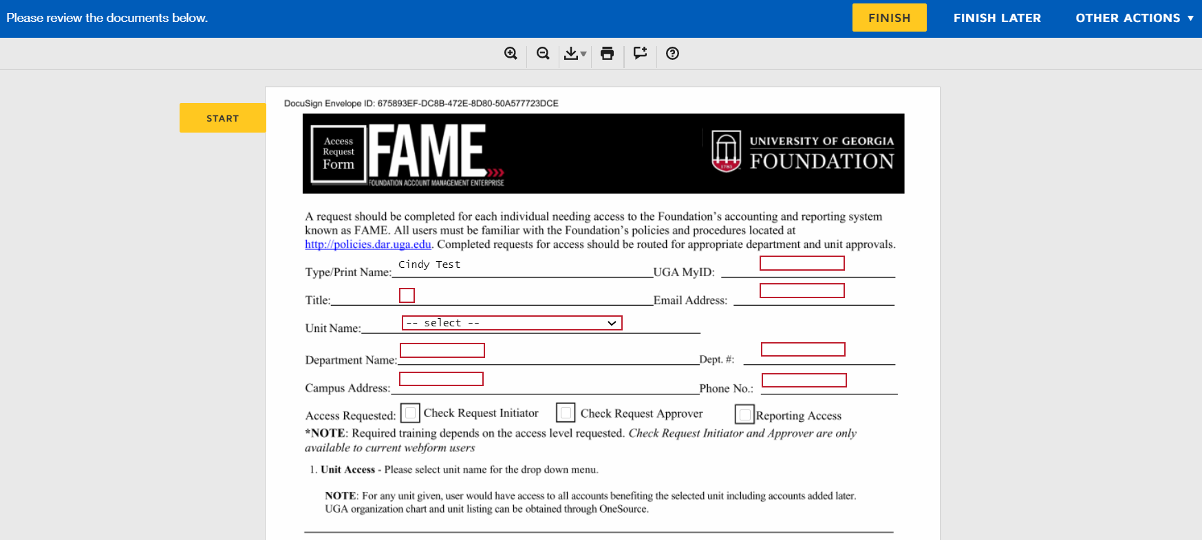
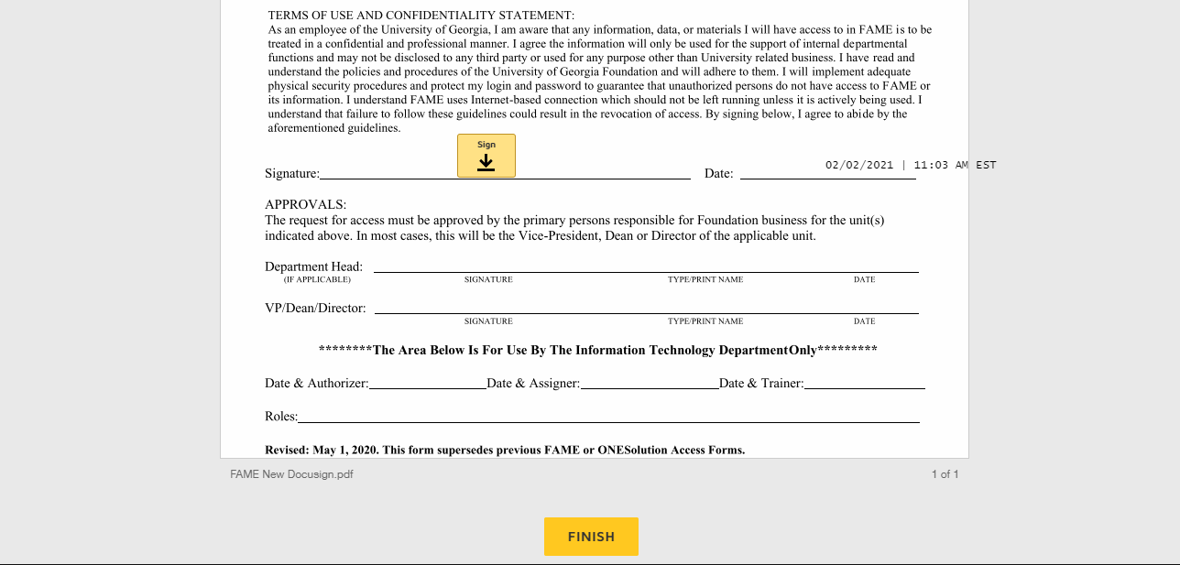

When you’ve finished entering data into all the required fields, you will Sign (electronically) and click the FINISH button. This action will deliver your form to your Department Head for their signatures via email (might check their spam folders). When the Department Head completes their part of the form, it will then move the form to the VP/Dean/Director for them to complete. From there, the form will deliver to our internal teams for processing and generating user access to the FAME system. Every person requesting access to FAME are required to attend FAME training, at the time of the scheduled training is when the user will receive their log in credentials. If someone misses their scheduled training, their access will not be available until they attend a FAME training class.
Please make sure you follow Step 2 in obtaining access to 02 Restricted VPN as you will need that to be able to access FAME with your log in credentials.

